Design of the national flag of Burkina Faso – Jacob Bollinger

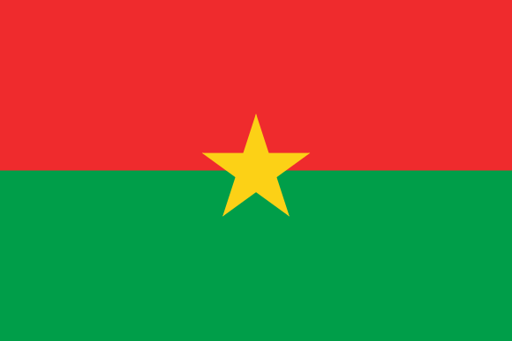

The flag of Burkina Faso is half carmine pink and half green with a metallic yellow star in the center. I first need to define the constants PINK, GREEN, YELLOW, SIZE, WIDTH, HEIGHT, RADIUS, and TITLE. I then need to create the function fillRectangle() to draw and fill rectangles. Then I need to use trig to create fillStar() to draw and fill the star. Next is to define the screen and turtle variables so I can see the flag and turtle can draw it. Finally us the fillRectangle() and fillStar() functions to create the flag.

The fillRectangle() code needs to tell turtle the pen color then tell turtle to go to the upper left corner. Then tell turtle to start filling the color and to go to the lower left corner, lower right corner, upper right corner, and finish in upper left corner.

The fillStar() function is much more complicated. First you will tell it to find 5 points on a circle with equal distance between. From there find the point where 2 lines through 2 points each intersect. Use this to create another circle inside the previous. Find 4 more points on the inner circle to have 5 points equally separated on it. Now tell turtle to connect all 10 points in the order that will create a 5-point star and fill it with the chosen color.

The next thing to do is to create the screen variables. These will create a screen to display the flag. Next to create a pink rectangle above the origin. Then create a green rectangle below the origin. Finally create a yellow star on the origin, and now you have the flag of Burkina Faso.